CN LAB 2
Muhammed Owais 23K-0047
Task 1:
Network Creation:
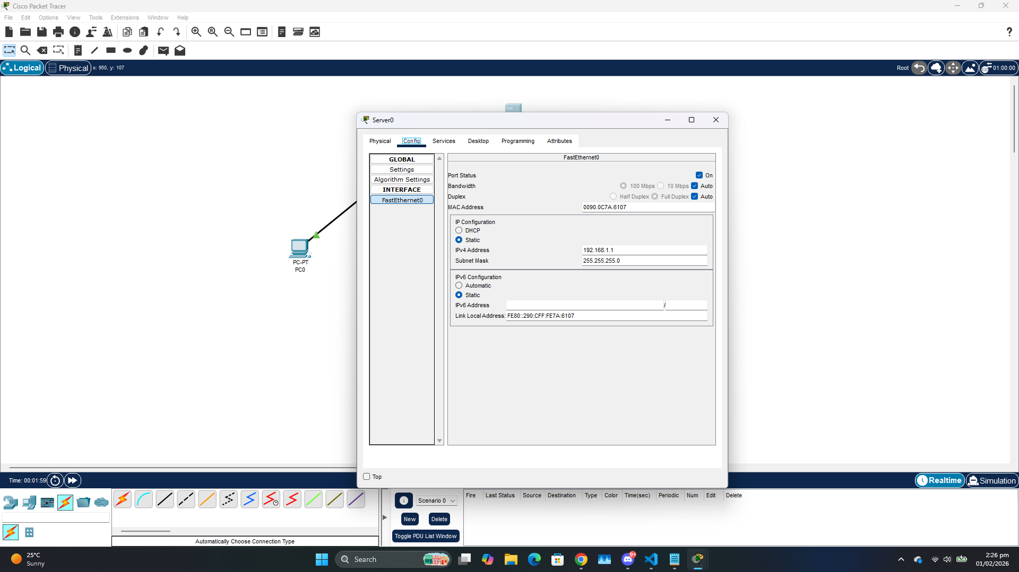
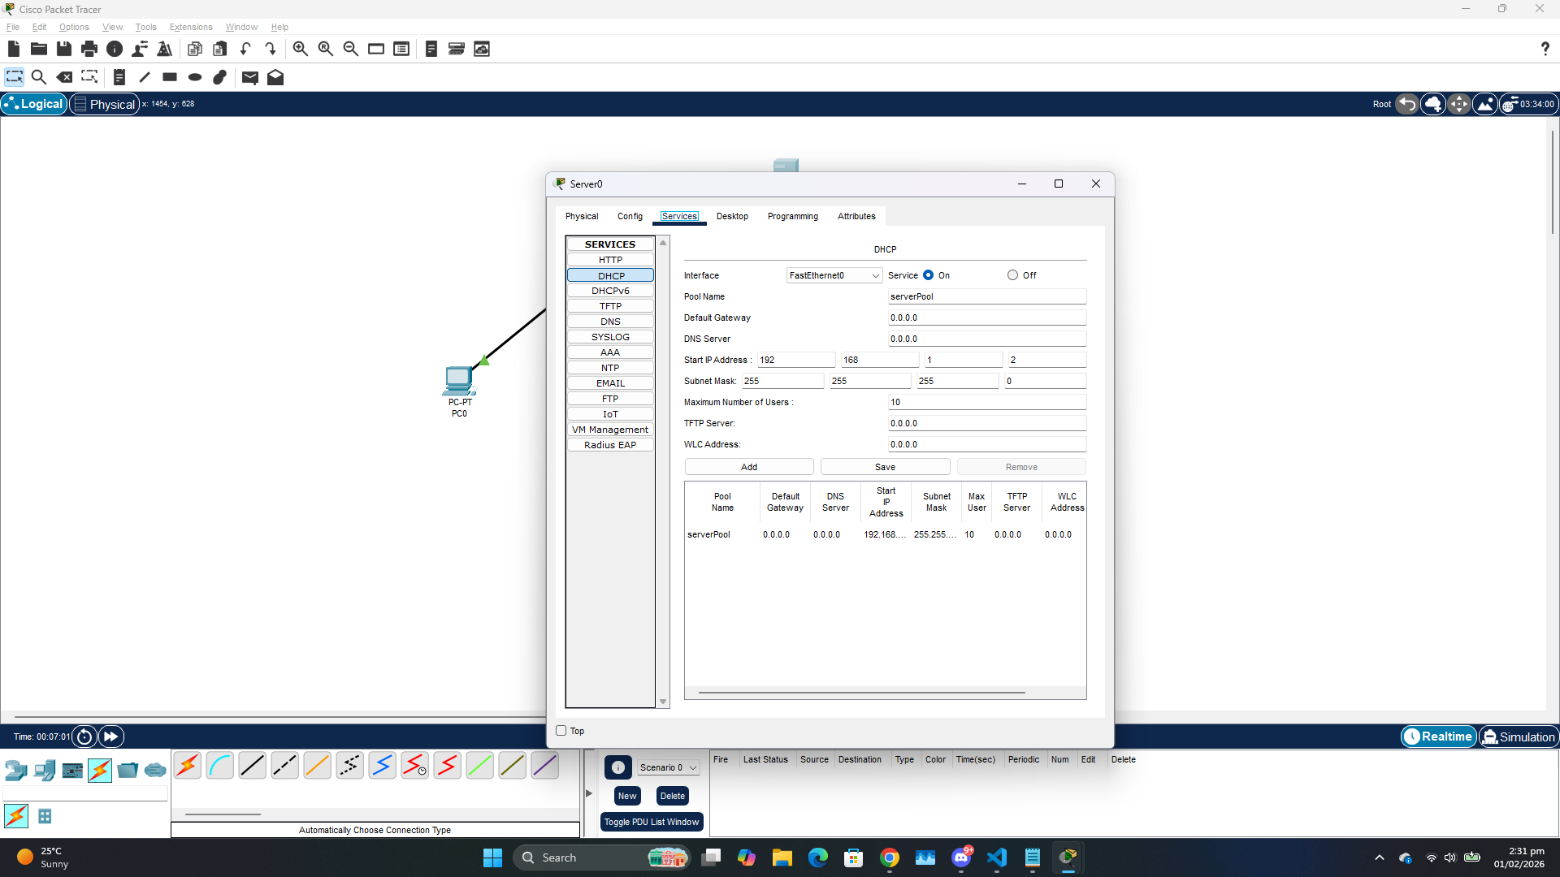
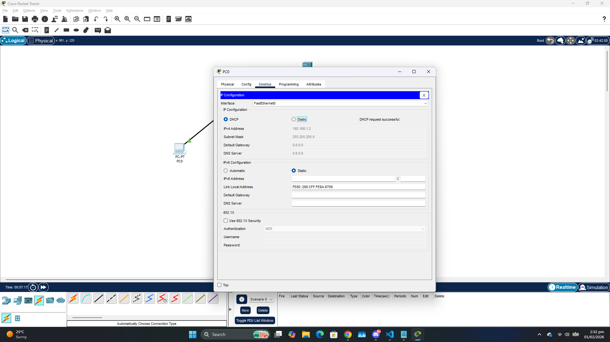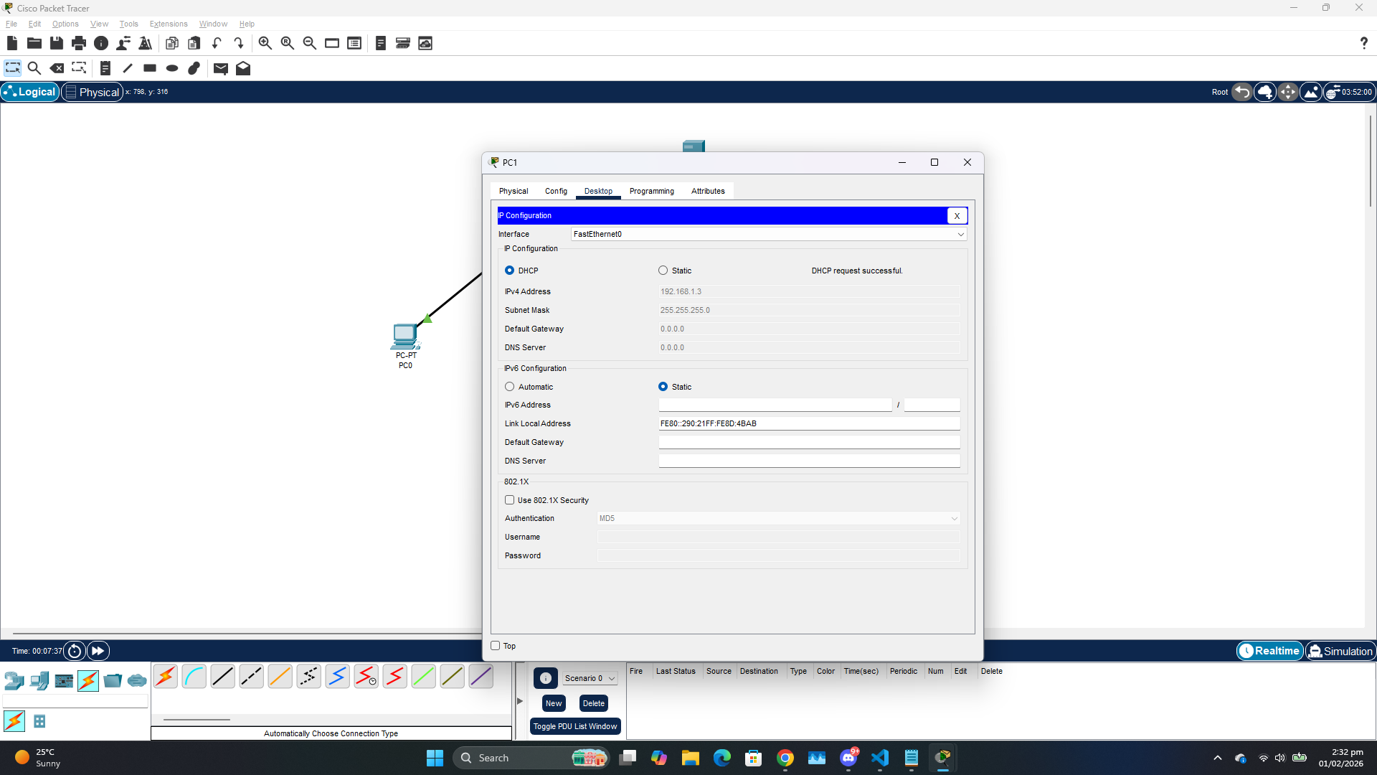
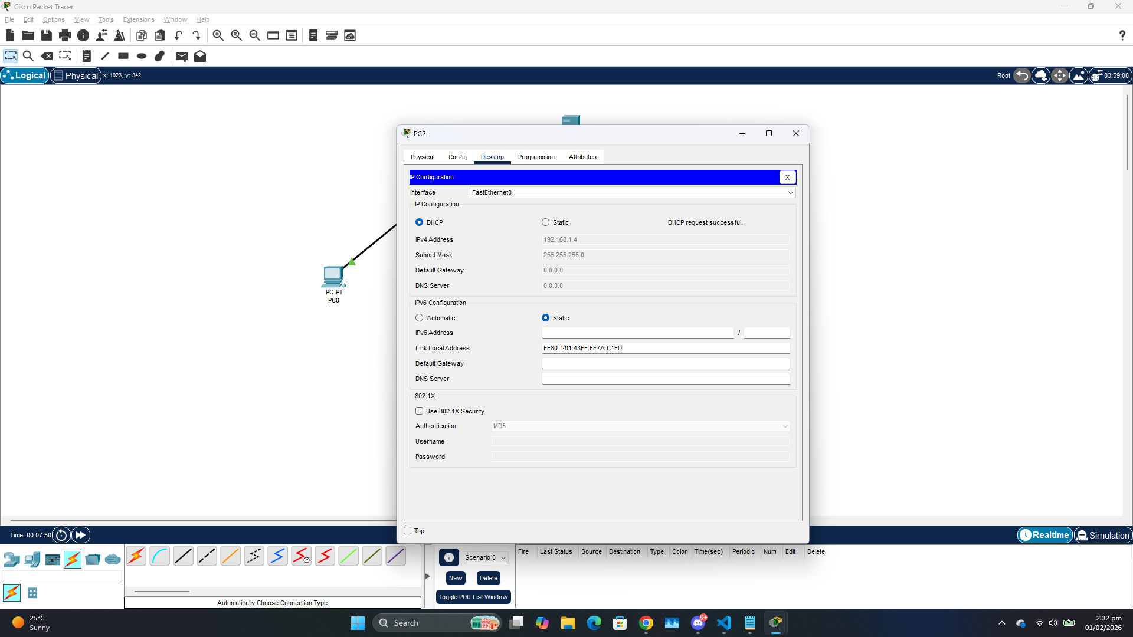
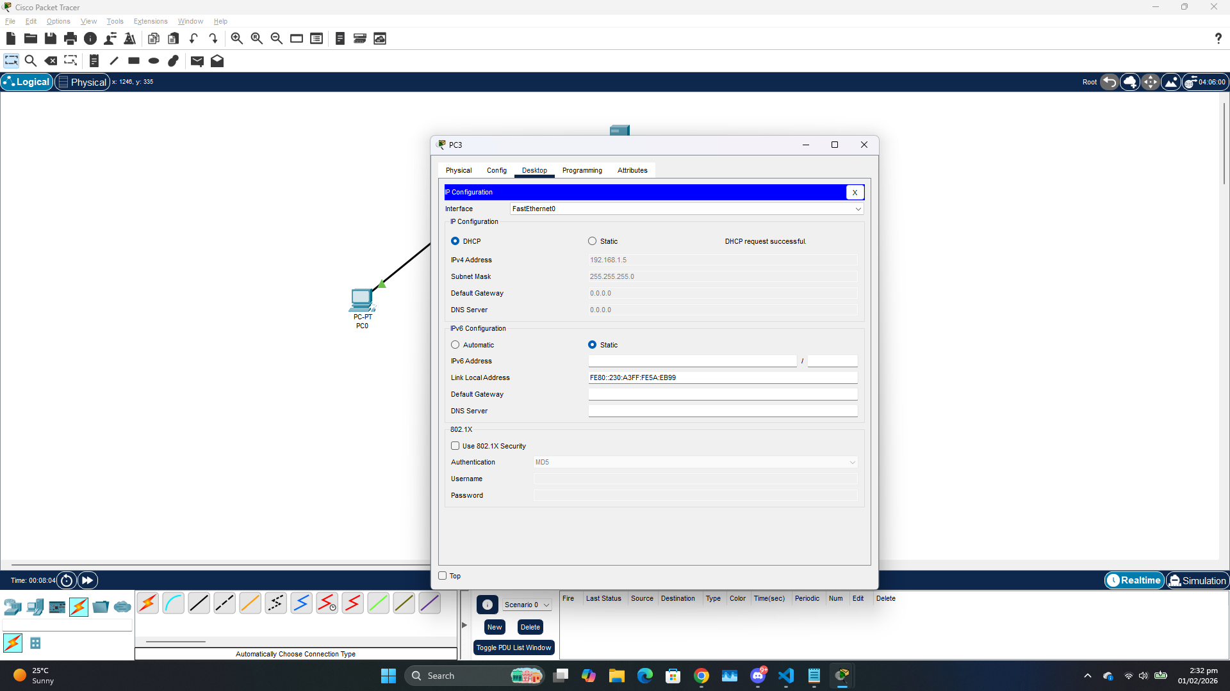

PING:
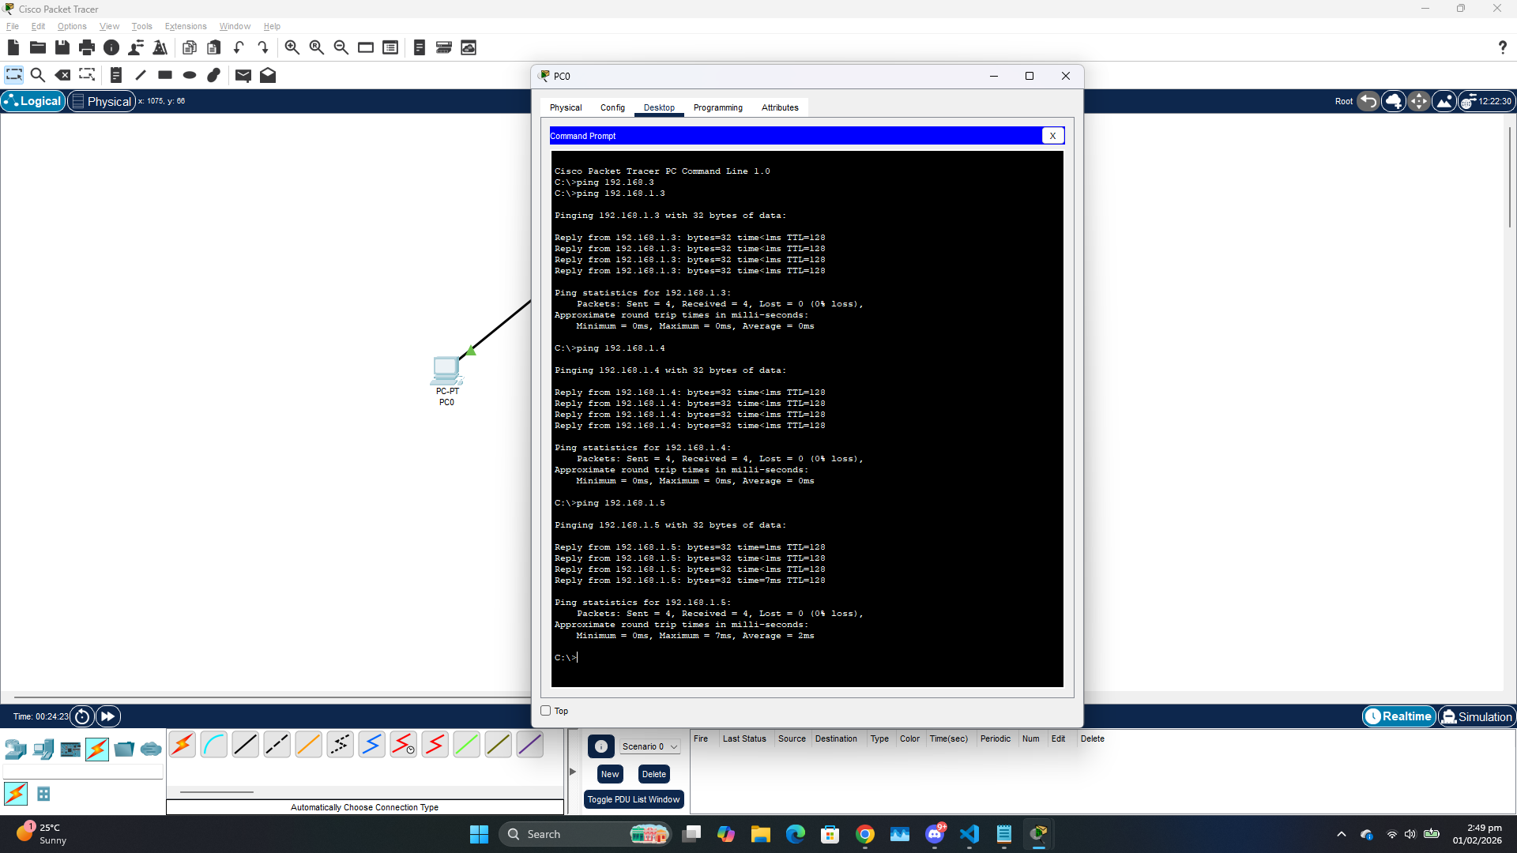

Devices Functionality:
PC:
It is an end device that is connected on a network (referred to as a node). It can be used to send or receive messages across a network. Just like any other node it has an IP Address that is unique to it.
Switch:
It is a network device that connects other devices on a network together by using packet switching to receive, process and forward destination devices. It also utilizes spanning tree protocol. It has CAM that stores mac addresses and filters PCs to which to send data based on that.
Server:
It can provide several services to devices that are connected to it such as DHCP, HTTP, Email. When acting as a DHCP server it automatically assigns IPs to the devices connected through it.

ARP Packet Header:
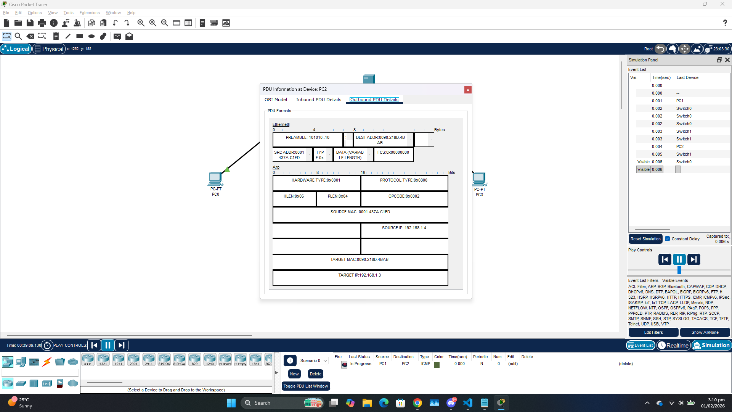

Task 2:
Switch acts intelligently and broadcasts messages only to the nodes that requested the message to be sent to whereas Hub sends the messages to all the nodes regardless. Switch is also more secure because it does not send messages to unintended nodes. Lastly, the hub shares bandwidth with all the connected devices at the same time whereas the switch has dedicated bandwidth.

Task 3:
1 : Straight through cable
2 : Straight through cable
3 : Serial Cable

Task 4:
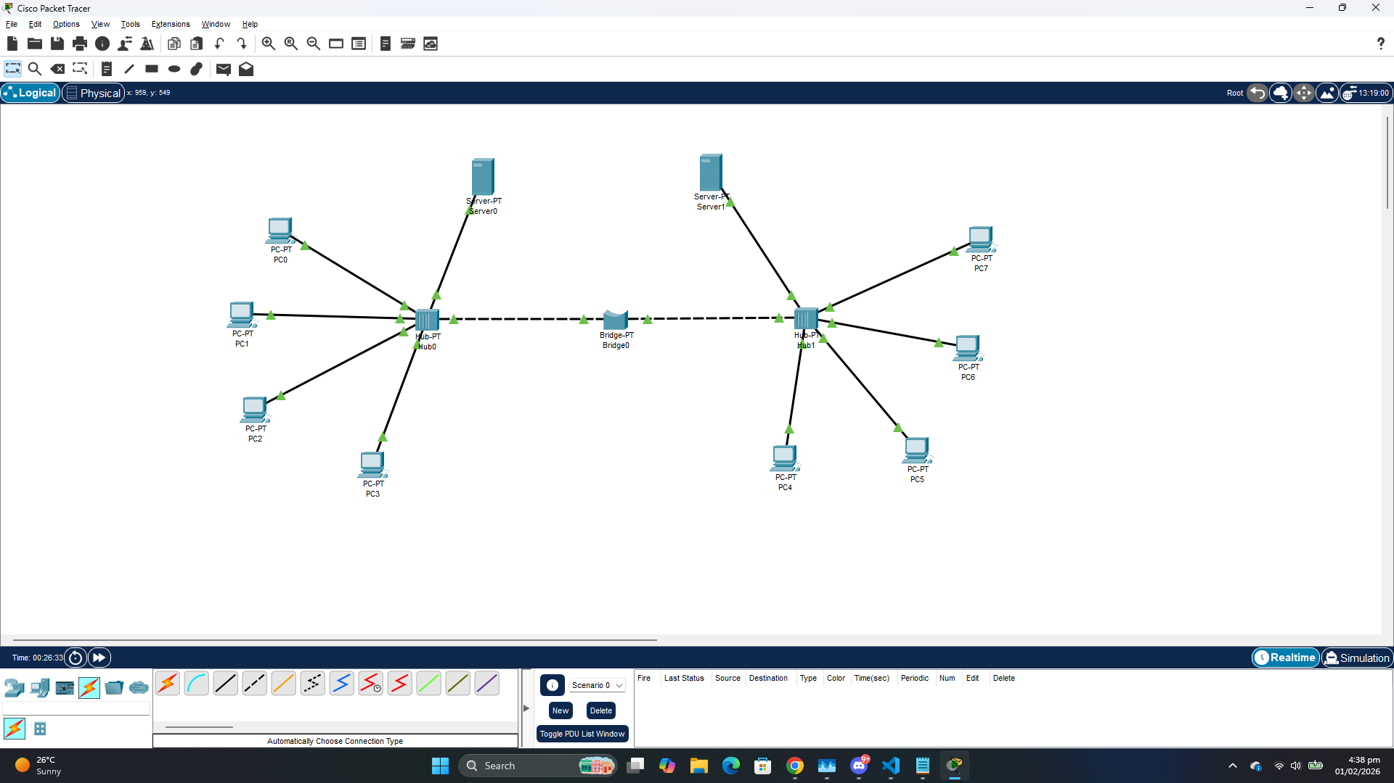
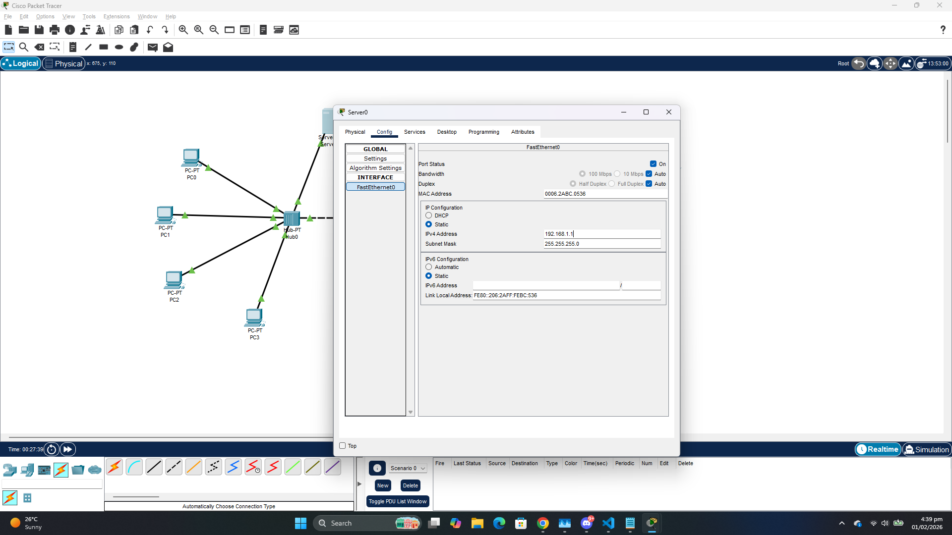
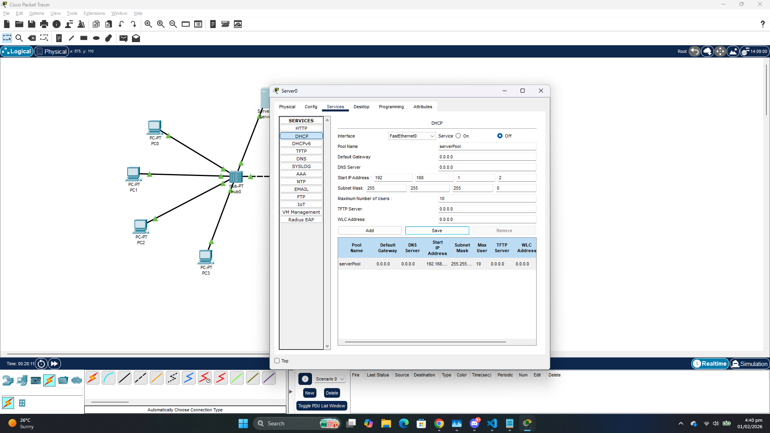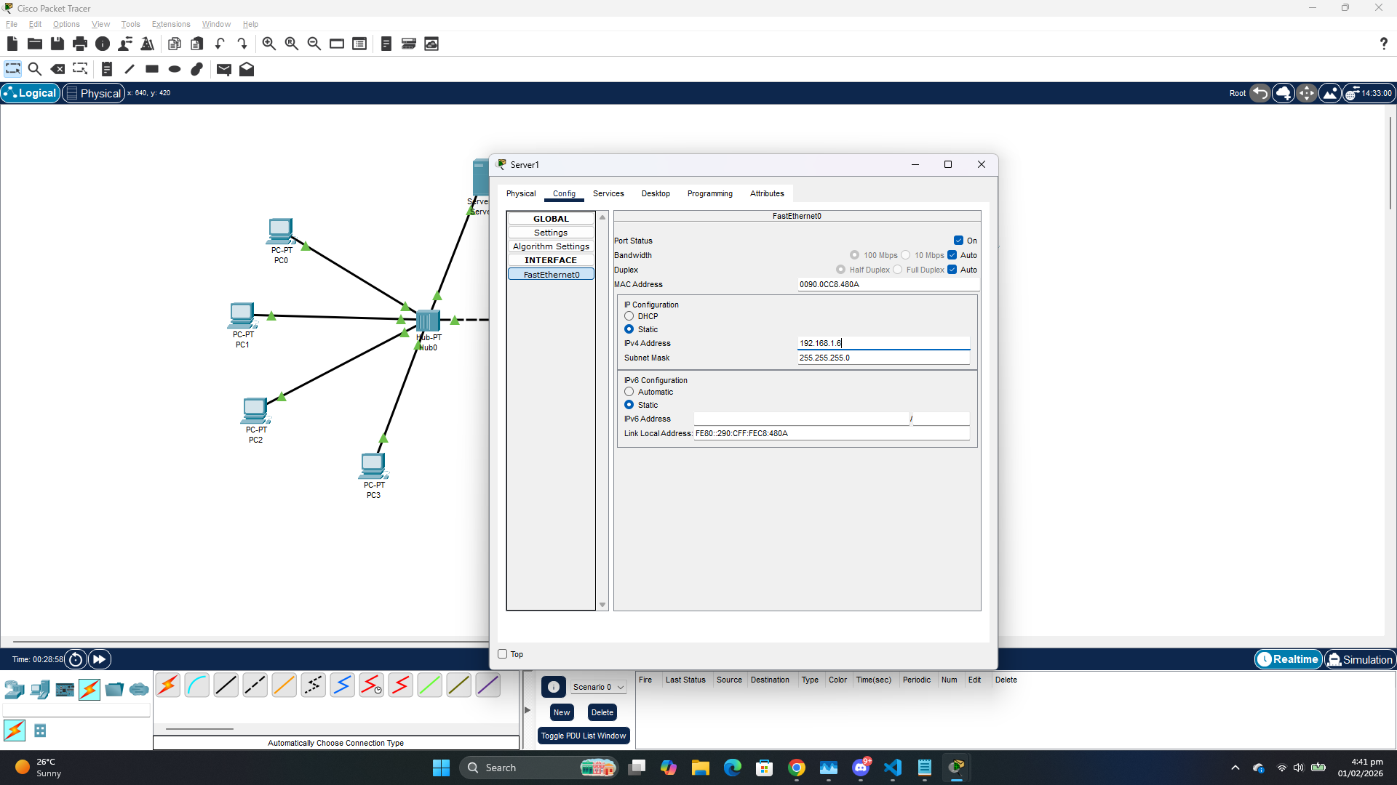
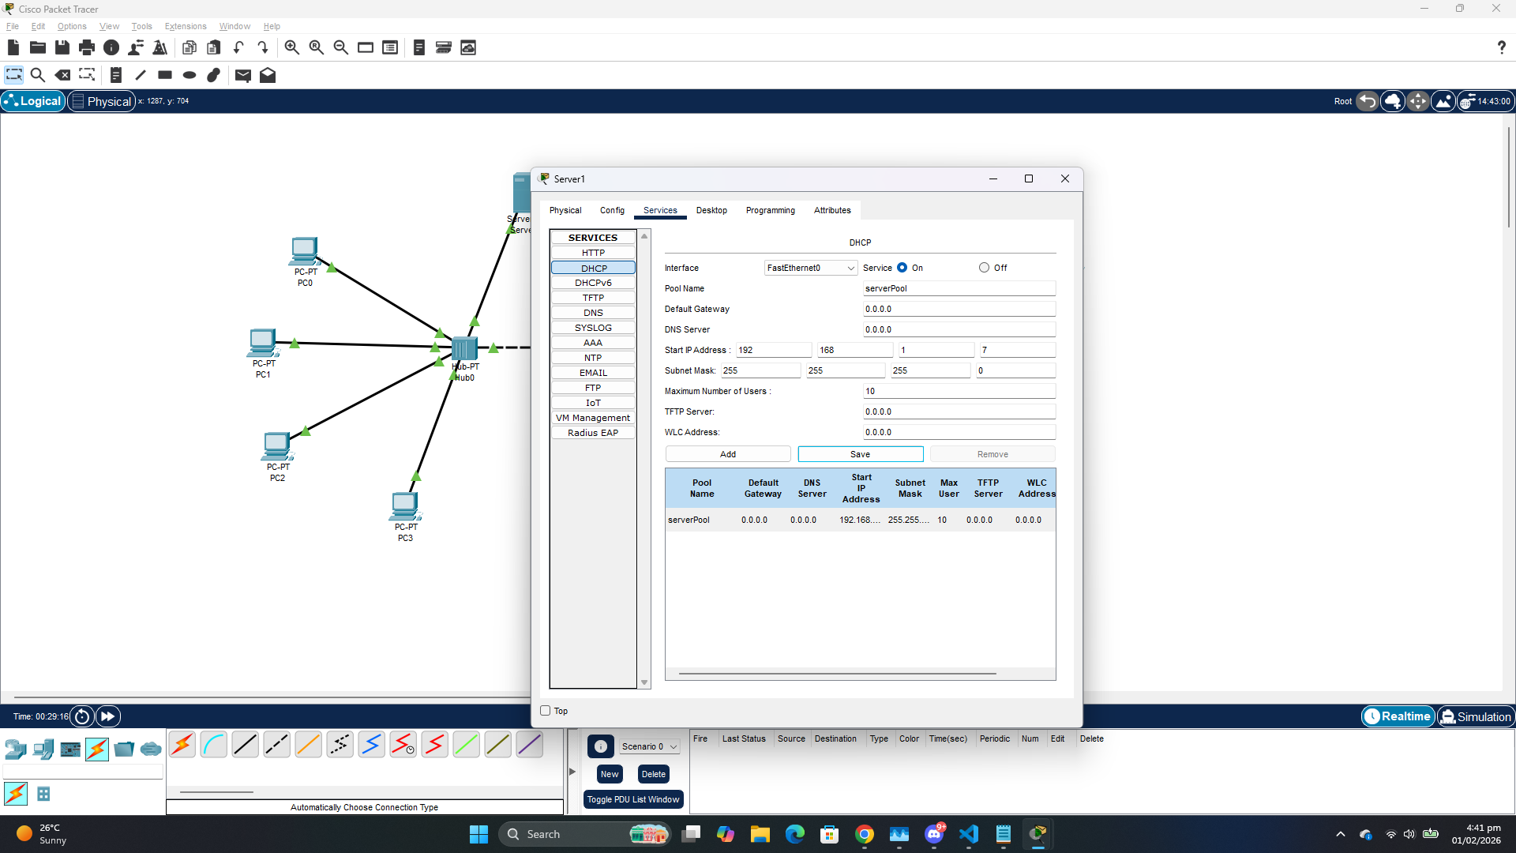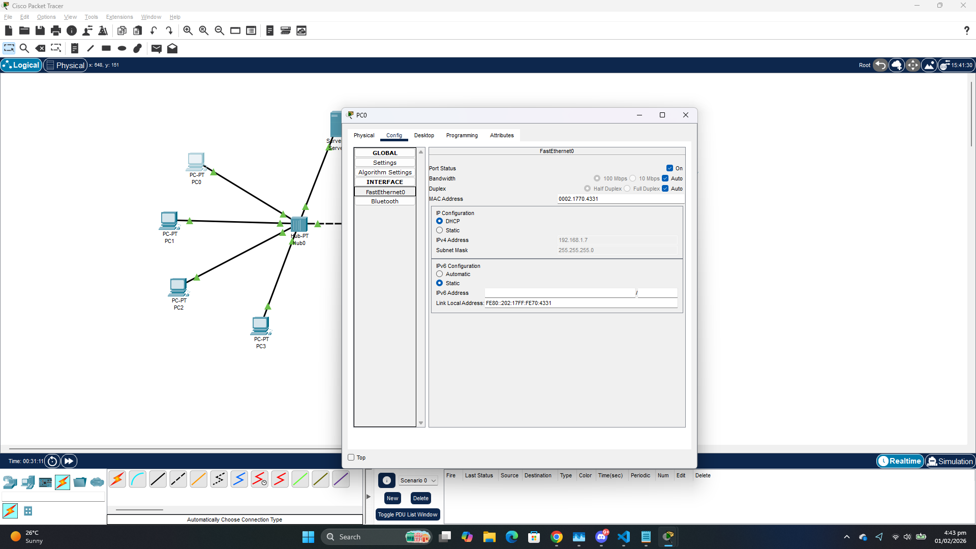

Bridge is a device that is used to connect multiple LANs together. It operates at the OSI model's data link layer and is also known as a layer of two switches. It basically examines the incoming traffic and determines whether to filter or forward it.

